ЗАДАНИЯ ДЛЯ СТУДЕНТОВ специальности 160100 НА Х СЕМЕСТР

Для сдачи зачёта (экзамена) студентам предлагается выполнение следующих заданий:
1) Перевод четырёх предлагаемых текстов с листа. (!!! Во время перевода тексов преподавателю можно пользоваться только списком слов с переводом.)
2) Контрольная работа №10 – первый текст не переводится - по тексту выполняются задания со II-VI, задание VII – грамматическое, письменный перевод текста в задании VIII.
3) Тема: “Airplane parts and their functions” – “Конструкция самолёта(детали и устройства и их функции)”
4) Перевод текста, предлагаемого экзаменатором.
Защита контрольных работ и перевода технических текстов проводится по расписанию во время сессии, а также в течение семестра по четвергам с 17.05 - 20.00. Тексты переводятся с листа: a) Вы читаете текст на английском языке, затем его переводите, глядя на английский вариант текста. Разрешается пользоваться, составленным вами словарем по предложенным текстам.
N.B. Просьба распечатать контрольные работы и тексты и принести их на зачет.
1) 4 текста на перевод с листа:

TEXT 1

General characteristic of the airplane parts.
(Part 1)
Airplanes are transportation devices which are designed to move people and cargo from one place to another. Airplanes come in many different shapes and sizes depending on the mission of the aircraft. The airplane shown on the picture below is a turbine-powered airliner which has been chosen as a representative aircraft.
For any airplane to fly, one must lift the weight of the airplane itself, the fuel, the passengers, and the cargo. The wings generate most of the lift to hold the plane in the air. To generate lift, the airplane must be pushed through the air. The air resists the motion in the form of aerodynamic drag. Modern airliners use winglets on the tips of the wings to reduce drag. The turbine engines, which are located beneath the wings, provide the trust to overcome drag and push the airplane forward through the air. Smaller, low-speed airplanes use propellers for the propulsion system instead of turbine engines.
To control and maneuver the aircraft, smaller wings are located at the tail of the plane. The tail usually has a fixed horizontal piece, called the horizontal stabilizer, and a fixed vertical piece, called the vertical stabilizer. The stabilizers' job is to provide stability for the aircraft, to keep it flying straight. The vertical stabilizer keeps the nose of the plane from swinging from side to side, which is called yaw. The horizontal stabilizer prevents an up-and-down motion of the nose, which is called pitch. (On the Wright brother's first aircraft, the horizontal stabilizer was placed in front of the wings. Such a configuration is called a canard after the French word for "duck").
At the rear of the wings and stabilizers are small moving sections that are attached to the fixed sections by hinges. Changing the rear portion of a wing will change the amount of force that the wing produces. The ability to change forces gives us a means of controlling and maneuvering the airplane. The hinged part of the vertical stabilizer is called the rudder it is used to deflect the tail to the left and right as viewed from the front of the fuselage. The hinged part of the horizontal stabilizer is called the elevator it is used to deflect the tail up and down. The outboard hinged part of the wing is called the aileron; it is used to roll the wings from side to side. Most airliners can also be rolled from side to side by using the spoilers. Spoilers are small plates that are used to disrupt the flow over the wing and to change the amount of force by decreasing the lift when the spoiler is deployed.

TEXT 2

General characteristic of the airplane parts.
(Part 2)
The wings have additional hinged, rear sections near the body that are called flaps. Flaps are deployed downward on takeoff and landing to increase the amount of force produced by the wing. On some aircraft, the front part of the wing will also deflect. Slats are used at takeoff and landing to produce additional force. The spoilers are also used during landing to slow the plane down and to counteract the flaps when the aircraft is on the ground. The next time you fly on an airplane, notice how the wing shape changes during takeoff and landing.
The fuselage or body of the airplane holds all the pieces together. The pilots sit in the cockpit at the front of the fuselage. Passengers and cargo are carried in the rear of the fuselage. Some aircraft carry fuel in the fuselage; others carry the fuel in the wings.
As mentioned above, the aircraft configuration in the figure was chosen only as an example. Individual aircraft may be configured quite differently from this airliner. The Wright Brothers 1903Flyer had pusher propellers and the elevators at the front of the aircraft. Fighter aircraft often have the jet engines buried inside the fuselage instead of in pods hung beneath the wings. Many fighter aircraft also combine the horizontal stabilizer and elevator into a single stabilator surface. There are many possible aircraft configurations, but any configuration must provide for the four forces needed for flight.

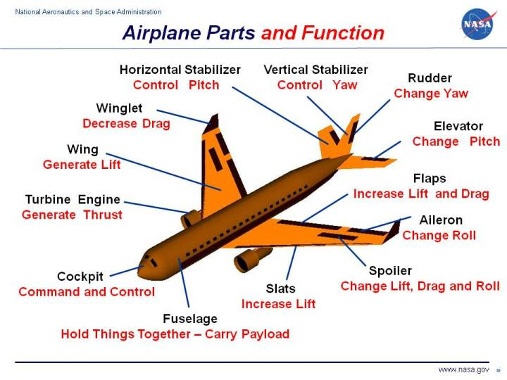

Vocabulary for the 1st and 2nd texts
aileron - элерон;
aerodynamic drag - аэродинамическое сопротивление;
canard aircraft - самолёт аэродинамической схемы «утка»;
cockpit - кабина лётчиков;
deflect - отклоняться, смещать;
deploy - перекладывать, выпускать, выбрасывать;
disrupt - искажать, срывать, прерывать, нарушать;
elevator - руль высоты, навеска руля высоты;
flap - щиток, закрылок;
fuselage - корпус самолёта;
horizontal stabilizer - хвостовой стабилизатор;
pitch - крен относительно поперечной оси;
pod - гондола двигателя, подвеска, транспортно-пусковой
контейнер;
propulsion system - система обеспечения движения, энергетическая
установка;
rear - хвостовая часть фюзеляжа;
rudder hinges - шарниры руля направления;
slat - (выдвижной) предкрылок;
spoiler - прерыватель потока, срывник, интерцептор;
turbine-powered - газотурбинный;
vertical stabilizer - хвостовая шайба, вертикальный стабилизатор, киль;
winglets - вертикальная шайба, законцовка крыла, винглет;
yaw - поворот в горизонтальной плоскости, вращение вокруг
вертикальной оси.

TEXT 3

Wings: construction and functions.

(Part 1 )
The wings are airfoils attached to each side of the fuselage and are the main lifting surfaces that support the airplane in flight. There are numerous wing designs, sizes, and shapes used by the various manufacturers. Most modern aircraft have all metal wings, but many older aircraft had wood and fabric wings. Wings may be attached at the top, middle, or lower portion of the fuselage. These designs are referred to as high-, mid-, and low-wing, respectively. The strongest wing structure is the full cantilever which is attached directly to the fuselage and does not have any type of external, stress-bearing structures. The semi cantilever usually has one, or perhaps two, supporting wires or struts attached to each wing and the fuselage. A few high-wing and most low-wing airplanes have a full cantilever wing designed to carry the loads without external struts. The number of wings can also vary. Airplanes with a single set of wings are referred to as monoplanes, while those with two sets are called biplanes. 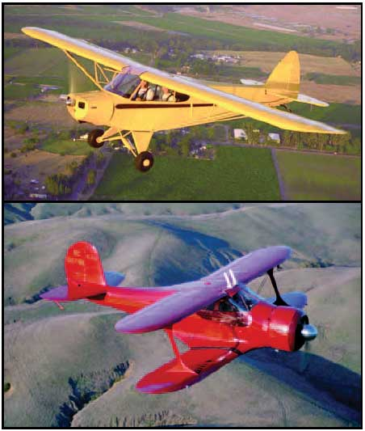
Figure1. Monoplane and biplane

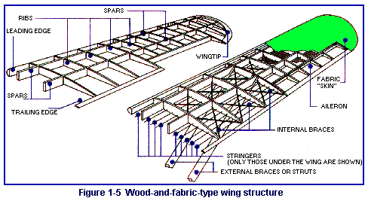
Figure2.Wood-and-fabric-type wing structure
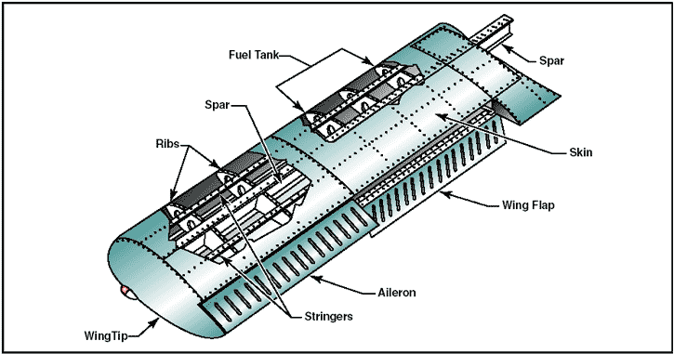
Figure3. Modern aircraft wings
To maintain its all-important aerodynamic shape, a wing must be designed and built to hold its shape even under extreme stress. So, the wing is a framework composed chiefly of spars, ribs, and (possibly) stringers. Spars are the main members of the wing. They extend lengthwise of the wing (crosswise of the fuselage). All the load carried by the wing is ultimately taken by the spars. In flight, the force of the air acts against the skin. From the skin, this force is transmitted to the ribs and then to the spars.

TEXT 4

Wings: construction and functions.

(Part 2 )
Most wing structures have two spars, the front spar and the rear spar. The front spar is found near the leading edge while the rear spar is about two-thirds the distance to the trailing edge. Depending on the design of the flight loads, some of the all-metal wings have as many as five spars. In addition to the main spars, there is a short structural member which is called an aileron spar.
The ribs are the parts of a wing which support the covering and provide the airfoil shape. These ribs are called forming ribs and their primary purpose is to provide shape. Some ribs may have an additional purpose of bearing flight stress, and these are called compression ribs. Attached to the rear, or trailing, edges of the wings are two types of control surfaces referred to as ailerons and flaps. Ailerons extend from about the midpoint of each wing outward toward the tip and move in opposite directions to create aerodynamic forces that cause the airplane to roll. Flaps extend outward from the fuselage to near the midpoint of each wing. The flaps are normally flush with the wing´s surface during cruising flight. When extended, the flaps move simultaneously downward to increase the lifting force of the wing for takeoffs and landings.
In most modern airplanes, the fuel tanks either are an integral part of the wing´s structure, or consist of flexible containers mounted inside of the wing.
The most simple wing structures will be found on light civilian aircraft. High-stress types of military aircraft will have the most complex and strongest wing structure.

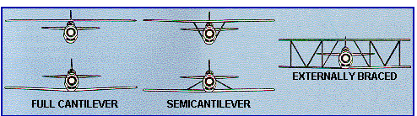

Vocabulary for the 3rd and 4th texts
airfoil - аэродинамическая поверхность, крыло;
attach - прикреплять, соединять, стыковать, отбортовывать;
compression rib - нервюра, воспринимающая нагрузку на сжатие;
cruising flight - полёт по маршруту, полёт на крейсерском режиме;
flap - щиток, закрылок
flush - подниматься, выравнивать, выпускать(резко);
full cantilever - консольное( крыло);
leading edge - передняя кромка крыла;
rib - типовая нервюра, ребро жесткости;
semi cantilever - полунавесное(крыло);
skin - зд. обшивка фюзеляжа;
spar - основная часть структуры крыла самолёта, идущая от вершины до
основания; стойка; штанга; балка; лонжерон;
stringer - продольный элемент жесткости, продольная балка,
strut - нога шасси, кронштейн, сжатый элемент конструкции, стойка;
trailing edge - задняя кромка крыла.

Контрольная работа № 10
по английскому языку для студентов специальности 160100(самолёто-, вертолётостроение) заочного отделения

VIII семестр

- Прочитайте и переведите текст (устно).

Cockpit
A cockpit or flight deck is the area, usually near the front of an aircraft, from which a pilot controls the aircraft. Most modern cockpits are enclosed, except on some small aircraft, and cockpits on large airliners are also physically separated from the cabin. From the cockpit an aircraft is controlled on the ground and in the air.
Cockpit as a term for the pilot's compartment in an aircraft first appeared in 1914. From about 1935 cockpit also came to be used informally to refer to the driver's seat of a car, especially a high performance one, and this is official terminology in Formula One. The term is most likely related to the sailing term for the coxswain's station in a Royal Navy ship, and later the location of the ship's rudder controls.
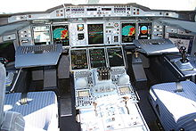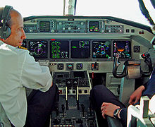

Airbus A380 cockpit. Swiss HB-IZX Saab 2000 cockpit

Most Airbus cockpits are computerised glass cockpits featuring fly-by-wire technology. The control column has been replaced with an electronic side stick.
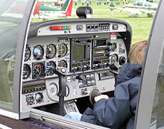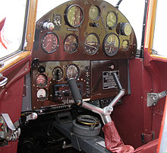

Robin DR400/500 1936 de Havilland Hornet Moth cockpit
The cockpit of an aircraft contains flight instruments on an instrument panel, and the controls which enable the pilot to fly the aircraft. In most airliners, a door separates the cockpit from the passenger compartment. After the September 11, 2001 terrorist attacks, all major airlines fortified the cockpit against access by hijackers.
On an airliner, the cockpit is usually referred to as the flight deck. This term derives from its use by the RAF for the separate, upper platform where the pilot and co-pilot sat in large flying boats.
The first airplane with an enclosed cabin appeared in 1912 on the Avro Type F however during the early 1920s there were many passenger aircraft in which the crew remained open to the air while the passengers sat in a cabin. Military biplanes and the first single-engined fighters and attack aircraft also had open cockpits, some as late as the Second World War when enclosed cockpits became the norm.
The largest impediment to having closed cabins was the material the windows were to be made of. Prior to Perspex becoming available in 1933, windows were either safety glass, which was heavy, or cellulose nitrate (i.e.: guncotton) which yellowed quickly and was extremely flammable. In the mid 1920s many aircraft manufacturers began using enclosed cockpits for the first time. Early airplanes with closed cockpits include the 1924 Fokker tri-motor, the 1926 German Junkers W.34 transport, the 1926 Ford Tri-Motor, the 1927 Lockheed Vega, the Spirit of St. Louis and the passenger aircraft manufactured by the Douglas and Boeing companies during the mid-1930s. Open-cockpit airplanes were almost extinct by the mid-1950s, with the exception of training planes, crop-dusters and homebuilt aircraft designs.

II. Выберите правильный вариант ответа на вопросы к тексту.
- What is another name for a cockpit?

a) flight deck;
b) airfoil;
c) flap.

2. When did a term “cockpit” for the pilot's compartment in an aircraft first appear?
a) in 1941 ;  b) in 1914;  c) in 1911. | b) 25 – 30
3. What does the cockpit of an aircraft contain?
a) wings;
b) slats;
c) flight instruments.

III. Закончите предложения по содержанию прочитанного текста.
4. Most Airbus cockpits are computerised … cockpits featuring fly-by-wire technology.
a) …glass…;
b) …brick…;
c) …ceramic….

5. The first airplane with … cabin appeared in 1912.
- ... separate...;
- ...an enclosed…;
- … removed....
6. During the early 1920s there were many … in which the crew remained open to the air while the passengers sat in a cabin.
a) … biplanes... ;
b) … military planes …;
c) … passenger aircraft ….

IV. Подберите эквивалент к данному русскому слову или словосочетанию .
7 . электродистанционная система управления
a) computerised | b) distinct | c) fly-by-wire
8. второй пилот
a) half-pilot | b) semi-pilot | c) co-pilot
9. боковая ручка управления  a) joy stick | b) low stick | c) side stick
10. экипаж
a) pilots | b) crew | c) company
11. самолёт-опыливатель
a) harvest aircraft | b) homebuilt aircraft | c) crop-duster
12. ударопрочное стекло
a) safety glass | b) nontoughened glass | c) spatter glass
13. кабина, отсек
a) capcake | b) compartment | c) cabinet

V. Выберите соответствующее определение данным словам из текста .
- tri-motor ; b) hijacker ; c) fortify ; d) extinct ; e) derive ; f) flammable ; g) access ; h) engine.

14. originate
15. reinforce
16. air pirate
17. motor
18. ignite
19. out of use
20. tri-jet
21. admittance

VI. Прочитайте предложения и укажите соответствует ли данное утверждение действительности: если соответствует напишите после предложения T- true, если не соответствует то F-false, при этом письменно подтвердите ваш ответ примером из текста.

22. From the cockpit an aircraft cannot be controlled in the air.
23. On an airliner the cockpit is usually referred to as the flight deck
24. From about 1935 cockpit came to be used informally to refer to the driver's seat of a car.

VII.
Выберите правильную видовременную форму глагола.

25. Cockpits on large airliners physically from the cabin.
a) are separated | b) is separated | c) can separated
26. The largest impediment to having closed cabins was the material the windows were / .
a) ) to make of | b) ) been made of | c) to be made of.

27.After the Second World War enclosed cockpits the norm.
a)will became | b) become | c) became

Выберите правильный предлог или союз.

28. The control column has been replaced an electronic side stick.

a) in | b) with | c) on
29. In the mid 1920s many aircraft manufacturers began using enclosed cockpits the first time.
a) for | b) at | c) above
30. A door usually separates the cockpit the passenger compartment.
a) from b) under c) to

VIII. Переведите текст письменно:
Cockpit windows may be equipped with a sun shield. Most cockpits have windows which can be opened when the aircraft is on the ground. Nearly all glass windows in large aircraft have an anti-reflective coating, and an internal heating element to melt ice. Smaller aircraft may be equipped with a transparent aircraft canopy.
In most cockpits the pilot's control column or joystick is located centrally (centre stick), although in some military fast jets and in some commercial airliners the pilot uses a side-stick (usually located on the outboard side and/or at the left).
The layout of the cockpit, especially in the military fast jet, has undergone standardization, both within and between aircraft different manufacturers and even different nations. One of the most important developments was the “Basic Six” pattern, later the “Basic T”, developed from 1937 onwards by the Royal Air Force, designed to optimise pilot instrument scanning.

