Министерство образования и науки Российской Федерации
Федеральное государственное бюджетное образовательное учреждение высшего образования
«Новосибирский государственный технический университет»

Английский язык
для магистрантов

Учебное пособие

Новосибирск
2018

Рецензенты:

Английский язык для магистрантов: учебное пособие / С. В. Никрошкина, Ю. В. Ридная; под общ. ред. Ю. В. Ридной. –???, 2018. – ??? с.

Данное учебное пособие предназначено для магистрантов технических направлений. Пособие направлено на развитие навыков чтения, письма говорения и восприятия иноязычной речи на слух, а также навыков аннотирования и реферирования. В рамках учебного пособия рассматриваются темы «Программы магистратуры в НГТУ и за рубежом», «Научная литература» и др. В зависимости от поставленной задачи данное пособие может быть использовано для контактной работы с обучающимися и при самостоятельной работе магистрантов.

Оглавление

Module 1 | MS program at NSTU | 4
Module 2 | Field of study | 10
Module 3 | Scientific Literature | 14
Appendix I |  | 17
Appendix II |  | 21
Appendix III |  | 22
Appendix IV |  | 30
Appendix V |  | 32

Module 1

MS program at NSTU

Reading and discussion

1.1. Answer the following questions:
a) What is a Master of Science degree awarded for?
b) How many Master’s programs does NSTU offer training in?
c) Is admission to an MS program competitive?
d) How long do students study at MS programs?
e) Is a thesis defense obligatory?

1.2. Read the text and check your answers.

MASTER OF SCIENCE PROGRAM AT NSTU

A Master of Science degree (or an MS for short) is a degree awarded at universities around the world for completion of graduate-level study in a science- or technology-related fields. The variety of different Master of Science programs at NSTU is overwhelming. NSTU has been awarding Master of Science degrees since 1996 and nowadays it offers Master’s programs in forty-nine fields of study.
Enrolling in an MS degree program is a significant instrument in one’s professional career. It enhances career prospects and gives industry oriented experience to its graduates. The philosophy of Master of Science program at NSTU provides practical, interdisciplinary skills and theoretical understanding of the chosen area. The MS programs are designed to be completed in 20-24 months.
Admission to an MS program at NSTU is provided on a competitive basis. First, the applicant’s suitability for the program is evaluated. To be eligible for admission in an MS program at NSTU, you must hold a Bachelor’s degree awarded by an accredited university. The degree program looks for applicants with excellent study success in their previous studies. Secondly, applicants have to pass tests in their majors and to meet the mandatory language requirements. The applicants are then ranked according to the grade point average and the best applicants are granted admission.
The curriculum comprises several credit courses, a non-credit seminar course and a Master’s thesis. Students attend lectures, laboratory works and seminars. The studies are closely connected with the relevant field. During the first semester students focus on the common subjects. During the second and third semesters students gain a deep insight into the chosen major. The course of study leads to the Master’s thesis at the end of the second year of studies. The elective courses are subject to advisor approval.
Each student admitted to the graduate program is assigned an academic advisor. Students work out the details of their program in close consultation with their advisors.
Choosing NSTU Master of Science degree program is a smart move for at least two reasons:
­ you can benefit from a complete learning experience;
­ you can study at the university placed highly on international rankings;
­you can take advantage of NSTU’s preferential relations with top employers;
­ you can live on a university campus with its numerous facilities.
After two years of studies and a thesis defense, students are awarded the Master of Science degree and can continue their research towards the Candidate of Science degree in engineering.

1.3. Read the text again and define the main purpose of the text. Is it to offer …?
- a detailed description of study program and admission requirements at NSTU MS program
- an argument for studying at NSTU
- an evaluation of NSTU graduates’ career prospects
- a comparison between MS programs at NSTU and other Russian universities
1.4. Answer the questions.
- What fields is the Master of Science degree usually awarded in?
- How long has NSTU been awarding Master of Science degree?
- What kind of experience does an MS program give to its graduates?
- What does the philosophy of Master of Science program at NSTU provide?
- What is the first requirement for the admission?
- Must an applicant’s Bachelor’s degree be awarded by an accredited university?
- What do the applicants have to pass?
- What does the curriculum comprise?
- What do students focus on during the second semester?
- When do the students defend a thesis?
- Who usually supervises the students’ research and studies?
- Can you enumerate the reasons for choosing NSTU Master of Science program?
1.5. Read the statements and say whether they are true (T) or false (F). Correct the false ones.
- A Bachelor’s degree is awarded for completion of Master of Science program.
- Nowadays NSTU offers Master’s programs in forty-nine fields of study.
- Enrolling in an MS program cannot actually help one’s career.
- A Master of Science program at NSTU provides only practical skills.
- Applicants to an MS program at NSTU do not have to take any special tests.
- The applicants are ranked randomly.
- Students attend lectures and seminars.
- The elective courses should be approved by a scientific advisor.
- Students work in close consultation with their supervisors.
- NSTU is placed highly on international rankings.
1.6. Give the English equivalents to the following words and phrases
- присуждать степень
- сферы, связанные с наукой и техникой
- важный инструмент в профессиональной карьере
- карьерные перспективы
- междисциплинарные навыки
- прием, зачисление
- на конкурсной основе
- обязательные языковые требования
- научный руководитель
- в тесном сотрудничестве
- обеспечивать чем-либо
1.7. Complete the sentences using the phrases from 1.6. The initial letters of words will help you.
- Students work in c… c… with their a… a… .
- A… to an MS program at NSTU is p… on a c… b… .
- Enrolling in an MS degree program is a s… i… in my p… c… .
- Students should meet the m… l… r… .
- Master of Science degree is a… around the world.
- Graduates work in a s… or t..-r… fields.

DEVELOPING ACADEMIC VOCABULARY
WORKING OUT THE MEANING OF UNKNOWN WORDS
1.8. The following words in the box are all from the text above. Find them in the text.
admission mandatory significant eligible to assign

1.9. For each word, read the sentence it occurs in and answer the questions.
- Is the word positive, negative or neutral?
- Is it a noun, adjective, adverb or verb?
- Can you think of a word with a similar meaning (synonym) and one with an opposite meaning (antonym)?
1.10. Match the words with their definitions.
- to award | - to give or allow someone something, usually in an official way
- overwhelming | - to give money or a prize following an official decision
- to enroll | - to improve the quality, amount or strength of something
- significant | - important or noticeable
- to enhance | - to decide a reason for something, to give a particular job or a piece of work to someone.
- admission | - having the necessary qualities or satisfying the necessary conditions
- eligible | - something that must be done or is demanded by law
- mandatory | - to put in an official list, to accept in such a list
- requirement | - permission to enter a place
- to grant | - very great or very large
- to assign | - what is wanted or needed by someone

GRAMMAR FOCUS
The passive
Academic texts typically contain a mixture of active and passive verb forms. You can decide to use the passive for a number of reasons, including:
- To keep the focus on the action, idea, object or event being described rather than who or what carries it out:
The mixture is inoculated with a starter culture…
- To avoid saying who did the action because it is unnecessary, obvious, or unimportant:
The mixture is filtered or racked to extract the sauce…
The Present and the Past Simple are often used in academic writing:
Present Simple
active: clean(s)/see(s) Somebody cleans the room every day.
passive: am/is/are cleaned/seen The room is cleaned every day.
Past Simple
active: cleaned/saw Somebody cleaned the room yesterday.
passive: was/were cleaned/seen The room was cleaned yesterday.
1.11. Look at the verb forms in italics in the text Master of Science program at NSTU. Write them out and state: a) their voice forms; b) their tense forms. Translate the sentences into Russian.
1.12. Make up sentences using the verbs and the patterns: [X is V₃]; [Xs are V₃]
Enroll develop assess choose admit
1.13. Transform the sentences from 1.11 and 1.12. according to the schemes:
X is V₃ > X was V₃ > X will be V₃
Xs are V₃ > Xs were V₃ > Xs will be V₃
ACADEMIC LANGUAGE. SENTENCE STRUCTURE.
Frequent sentence patterns
The most frequent sentence patterns in English are simple and compound.
Sentences are built up using one or more clauses. A clause has a subject, verb ,object, complement, and adverbial. This is an example of a simple sentence with one main clause:

Students work with their supervisors.
They attend lectures, laboratory works and seminars.
Two clauses can be joined to create a compound sentence using a coordinator. There are three main coordinators: and, but and or. For instance:
Some students learn in a different way from others and so need to be taught in a way that makes it easy for them to learn.
1.14. Put the words in the correct order. Use the sentences to speak about your Master of Science program of studies.
- Awarding/ NSTU/ has/ of/ Science/ degree/ been / since/ Master/ 1996.
- Entered/ I/ research-oriented/ have/ a/ program.
- Major/ is/ physics/ my/ theoretical.
- Well/ I/ am/ informed/ this/ problem/ on.
- Moreover/ collecting/ I/ am/ on/the material/ the problem.
- Significant/ is/ Master/ of/ instrument/ Science/ prospective/ program/ a/ career/ my /in.
- Me/ it/ provides/ practical/ theoretical/ with/of/ area/ chosen/ and/ understanding/ the.
- An/ to / Admission/ MS/ program/ competitive/ was.
- In/ majors/ as well as/ I/ to/ had/ pass/ a test/ in/ English/ in/ my.
- Admission/ granted/ I/ results/ had/ excellent/ I/ and/ was.
- Closely/ my/ studies/ are/ now/ connected/ with/ field/ relevant/ the.
- Attend/ seminars/ works/ I/ laboratory/ and.
- Also/ take/ I/ part/ in/ conferences/ scientific.
- Ivanov/ is/ academic/ Professor/ my/ advisor.
- Work out/ I/ of/ my/ program/ in/ close/ the details/ consultation/ with/ him.
- Hope/ to/ I/ my/ Master’s/ defend/ thesis/ in/ years/ two.
LISTENING
1.15. You are going to watch an introduction to a lecture Graduate Employability given by Dr Siobhan Cleary. For questions 1-3 choose the correct answer: a, b or c.
- The series of lectures is looking at
- the work of engineering graduates
- the relationship between course content and graduate employability
- the prospects of engineering careers
- Last week the lecturer talked
- about the salaries of university graduates
- about the development of communication skills
- about why students study science and engineering in the first place
- The purpose of the lecture is
- to give a brief summary of expert views
- to survey how well the course of study equips students to become successful
- to tell the students about employers’ expectations

  - What did the lecturer do in the introduction? Tick (ˇ) the correct answers.

- She introduced herself.
- She spoke about the curriculum.
- She stated the purpose of the lecture.
- She spoke about creative abilities.
- She explained the organization of the lecture.
- She welcomed the audience.
- She explained the content of the lecture.

  - You are going to watch Extract 2 of the lecture Graduate Employability given by Dr Siobhan Cleary. For questions 1-6 choose the correct answer, a, b or c.
- The lecturer is going to
- speak about employment prospects
- speak about current skills
- speak about her own job experience
- After narrowing down a shortlist of the most important skills comprised
- fifty different skills
- six key skills
- five key skills
- The interviewees named the most important job skill(s). According to them,
- it is spoken communication
- these are communication skills except presentation ones
- these are communication skills encompassing both spoken and written communication, and presentation skills
- Employers expect graduates to have
- good engineering skills
- good communication skills in all areas
- both communication and engineering skills
- Technical ability is
- connected with people managing skills
- means being able to understand technical issues
- the desire to expand your technical knowledge as well as the ability to understand technical problems
- According to the lecturer, people-based skills
- are natural and do not need to be developed
- should be nurtured in everyday life
- should be developed during the period of academic studies
1.18.Watch Extract 2 again and decide what skills were NOT mentioned in the lecture.
- The ability to solve the problems
- The ability to deal with people
- The ability to memorize information fast
- The ability to analyse well
- Brilliant mathematical skills
- Creativity
- Having technical ability
- The ability to communicate well
1.19.Make up a list of 5 top skills you consider to be important for a modern engineer. Explain your choice.
1.20. Tell about MS program at NSTU.
MODULE 2
Field of study
Reading and discussion
2.1. Answer the following questions.
- What are key skills in today̕s marketplace?
- What is at the core of any business organization?
- Should IT students be provided with both solid technical foundation and sound practice?
- What positions in IT fields do you know? Can you enumerate them?
- Do you think that Master of Science in Information and Technology (MSIT) graduates can easily find a job?
2.2. Read the text Master of Science in Information and Technology and check your answers.

Master of Science in Information and Technology
California Lutheran University

Overview
Data, analytics, and management of Information Technology are key skills in today’s marketplace. Our MSIT program provides students with a solid and forward-thinking technical foundation used to effectively plan, design, implement and manage IT systems.

Quick Facts
MSIT prepares students to be strong technical leaders, ready to lead IT-enabled organizational change. The program is designed to be constantly relevant and practical for working professionals.

Careers in Demand
A Master’s in Information Systems is considered by Forbes Magazine to be “The Best Master’s Degree,” with a projected employment growth of 30 percent through 2020. The Occupational Outlook Handbook places various IT careers in five of the top 20 growth positions nationwide, and in seven of the top 10 positions in terms of job growth in Los Angeles County.
“Earning this degree was holistic – it's helped me to have a broader perspective of IT management, business, and the global industry. With the knowledge obtained, I believe I can offer valuable contributions to any company I work with.” Barbara Guarnieri

Program Highlights

Information Technology (IT) is pervasive today and is at the core of almost any business organization. The Master of Science in Information Technology program (MSIT) is designed to provide students with a solid and forward-thinking technical foundation used to effectively plan, design, implement and manage IT solutions and systems. It prepares students to be strong technical leaders, ready to lead IT-enabled organizational change.
The MSIT program targets both technical professionals wishing to advance their career in the field as well as business professionals wishing to gain valuable IT skills needed to transform enterprise operations. The curriculum is carefully designed to combine the study of fundamental theory with sound practice, applying latest technologies and tools to real-world problems in the comfort of the classroom.

Get Experience with Big Data
Providing timely and relevant information requires working with real-world data. Lots of data. Big data. That's why Cal Lutheran students have access to invaluable research resources, including a fully functional data processing cluster and actual, real-world data sets.

A Growing Job Market
The job market for IT professionals is forecast for continued growth. The Occupational Outlook Handbook places various IT careers in five of the top 20 growth positions nationwide, and in seven of the top 10 positions in terms of job growth in Los Angeles County.
As an MSIT graduate, you will be prepared for a number of positions in the IT field including:
- Business/Systems Analyst
- IT Project Manager
- Data Analyst
- Business Intelligence Analyst
- System Developer
- Information Systems Manager
- Chief Information Officer
- IT Consultant
- Security Consultant
- Network Analyst/Administrator

Curriculum
The curriculum includes a total of 12 graduate courses (36 credits) total. Students will take eight core courses and four elective courses in their specialized track. Students can obtain a general MSIT degree by selecting elective courses across tracks. Students with backgrounds that are not in Information Technology (IT) or business may need foundation courses which do not count towards the 36 credits required for the degree.

Course Terms & Calendar
On-campus courses are offered year-round in four, 11-week terms. The on-campus option appeals to those students living in the area who prefer face-to-face, evening classes or find value in taking a combination of on-campus and online classes.
On-Campus Terms
Fall Term | September-November
Winter Term | December-February
Spring Term | March-May
Summer Term | June-August

https://www.masterstudies.com/Master-of-Science-Information-and-Technology/USA/California-Lutheran-University/
2.3. Define the main purpose of the text. Is it to offer …?
- a detailed description of study program and admission requirements at California Lutheran University MSIT program
- an argument for studying at California Lutheran University
- an evaluation of MSIT graduates̕ job possibilities
- a comparison between MSIT programs in Russia and abroad
2.4. Answer the questions:

- What does MSIT program provide students with?
- How long does the program of study last?
- Are there any options available for students who cannot study full-time?
- What magazine considers MSIT to be "The Best Master’s Degree"?
- Who does the MSIT target?
- What does the curriculum of study combine?
- Can MSIT graduates find a job easily?
- What positions are MSIT graduates prepared for?
- What language does this university offer programs in?
- When can the students start the program?
2.5. The following words in the box are from the text above. Find them in the text.
admission implement availability pervasive solid

2.6. For each word, read the sentence it occurs in and answer the questions.
- Is the word positive, negative or neutral?
- Is it a noun, adjective, adverb or verb?
- Can you think of a word with a similar meaning (synonym) and one with an opposite meaning (antonym)?
2.7. Find two synonyms to the words given
- apply: a) administer; b) determine; c) bring into use; d) employ
- valuable: a) costly; b) precious; c) bright; d) irreplaceable
- implement: a) bring about; b) carry; c) accomplish; d) achieve
- relevant: a) loyal; b) connected; c) applicable; d) essential

2.8. Give the English equivalents to the following words and phrases
- ключевые навыки
- иметь доступ к бесценным исследовательским ресурсам
- эффективно планировать, разрабатывать применять на практике и управлять информационными решениями и системами
- преобразовывать деятельность предприятий
- сочетать изучение фундаментальной теории с серьезной практикой
- применять новейшие технологии и инструменты для решения сегодняшних проблем
2.9. Complete the table with appropriate word forms.
VERB | NOUN | ADJECTIVE
to describe | - description | descriptive
to apply | 1) | 2)
3) | comparison | 4)
to manage | 5) | 6)
to value | 7) | 8)
9) | argument | 10)

GRAMMAR FOCUS
2.10.Rewrite the sentences using the verb phrases in italics in the passive according to the schemes:
S Vs O > O is V₃ (by S)
S Vs Os > Os are V₃
Ss V Os > Os are V₃
Ss V₂ Os > Os were
S V₂ O > O was V₃
- Somebody carries out experiments regularly.
- Somebody uses the laboratory every day.
- We often refer to poorer countries as "developing countries" .
- They illustrated these ideas.
- People thought of power as a dangerous concept.
- This essay made clear some distinctions in the research.
2.11.Translate into Russian using the academic vocabulary from the text.
- Ключевые навыки используются учеными в этом исследовании.
- Управление предприятием преобразовывается группой менеджеров.
- Изучение фундаментальной теории с серьезной практикой сочетается в этой учебной программе.
- Новейшие технологии и инструментарий были применены в его работах.
- Его исследование было эффективно спланировано, разработано и применено на практике.
Compound adjectives
A compound adjective is an adjective that includes more than one word. We put a hyphen two or more words when we want them to act as a single idea: remote-controlled (с дистанционным управлением), low-paid (низкооплачиваемый).
2.12.Study the phrases from the text Master of Science in Information and Technology, try to translate them:
forward-thinking foundation
IT-enabled organizational change
real-world problems/ data
2.13.Translate into Russian.
Brand-new, red-brick, well-balanced, trouble-free, labor-saving, present-day, long-distance, four-door, five-page, right-angled, cross-channel, nuclear-free, freeze-dried, mass-produced, cast-off, life-size, well-known.
2.14. Translate into English using the compound adjectives given.
ill-equipped more-qualified time-consuming well-equipped hard-working full-scale two-year air-conditioned
- Этот эксперимент длителен и полномасштабен.
- Наша лаборатория хорошо оборудована и кондиционируема, поэтому мы работаем быстро и эффективно.
- Если вы хотите выучить испанский, вы должны записаться на двухгодичные курсы.
- Он является ярким примером упорного ученого.
- Эта больница плохо оснащена, но персонал высококвалифицированный.
2.15. Answer the question on your field of study
1.What is your field of study? Give the name of MS program you are taking at the moment.
2.Why did you choose it?
3.What are the main notions of your field of study?
4.What are the subfields in this area?
5.What is the background of your field of study?
6.What scientists made the greatest contribution to your field of study?
7.What are the recent achievements in the field?
8.What is the practical significance of results achieved in your field of study?
9.What branches of industry is your field of study connected with?
10. What subjects should specialists in your field of study learn? Where do specialists in your field work?

2.16. Find information on MS programs similar to yours at foreign universities. Compare these two MS programs according to several criteria and complete the table

MS program in …… at NSTU | MS program in ….. at …..(a foreign university)

2.17. Discuss these two programs with your partner. (Role-play: student1- a master student at NSTU; student 2 – a master student at a foreign university).

MODULE 3

Scientific Literature
.
Reading and writing
  - Scan the scientific article/paper and analyze its structure (See Appendix I). What are the main components of the article? Make up a plan/ scheme -model of the article.
  - Compare the scheme -model of your own with the scheme-model of a scientific article from Appendix II.
  - Complete the table below (Literature Review Chart) on the content of the article.

Literature Review Chart

Citation information

Purpose/ Problem

Subject

Methodology

Results and conclusions

Contribution
  - Select 5 research article on your field of study. Complete Literature Review Chart for each article.

Reading and Summarizing

3.5. Read Theoretical Review on abstracting and summarizing (See Appendix III). Define the difference between a summary and an abstract.
3.5. Before reading the text answer the question : “What is electronics?”
3.6. Read the text and find the answer to the question.

Learning about electronics

Electronics is quite a complicated subject, taking in some physics, some chemistry, some mechanical engineering, and even some drawing. There is a lot to learn, but the most important part of learning the subject is understanding the underlying principles. Once you have mastered these, learning the rest of it is relatively easy.
It is possible to put a lot of mathematics into electronics, but it isn't necessary to an understanding of the subject. Of course, mathematics is necessary when calculating what voltages, currents and components your circuits use, but the calculations are really very simple: more 'arithmetic' than 'mathematics'.
A study of electronics can be divided, broadly, into three rather separate disciplines: electricity, analogue electronics and digital electronics.
Electricity is basic to the whole thing; you need to know a certain amount about electricity before you can begin to understand anything about the way electronic devices work. And before you do much work with electricity, you must learn about safety.
Analogue electronics (or analog, which is the American spelling) is the study of systems in which electrical quantities vary continuously. Examples are radio, record and tape players, and television receivers.
Digital electronics is the more recent aspect of the subject, and deals with electrical quantities that vary in discrete steps instead of smoothly. Many digital systems deal with only two possible values. The most important example is digital computers.

3.7. Complete the graph of the text:
3.8. Divide the text into two subtexts. What are they? What is the function of the crossed sentence in the structure of the whole text?
3.9. Summarize the underlined sentences using the patterns:
Х is a material that … | => | The author describes X as a material that …  X is considered as a material that …
3.10. Write a summary (1). Use Appendix IV

3.11. Look at the title of the text. What do you thing the text is about?
3.12. Read the text and fill in the gaps (1–4) with the sentences (A–D) below. Pay attention to the means of connection.

Generation of electricity

Historically, knowledge of electrical manifestation goes back to the early Greeks who noticed that amber, after being rubbed, had the power to attract feathers or small bits of straw. Through the ages many people have experimented with and studied the nature of this strange power, and by their efforts it has been brought under control and made one of man's most useful servants.
(1) ___________________________________________________.The explanations given here are made as simple and nontechnical as possible.
Electromotive force (emf) is the force or pressure that causes electric current to flow. The unit of measure of this force is the volt. Electromotive force is sometimes called "potential" or "voltage". Electric current will flow in a wire when sufficient voltage is present. (2) __________________ ___________________________. Volts and amperes are measured by dial instruments called voltmeters and ammeters.
The amount of electric power that is delivered by a generator or is consumed by a motor or other power device is the product of the pressure and the flow. (3)________________. The unit of measure of power is the watt. Therefore, watts = volts x amperes. Instruments for indicating or recording watts are called wattmeters. (4) ________________________________.
A. Thus, power = volts x amperes.
B. Before studying the way in which electrical power is generated, certain terms must be explained and certain manifestations must be discussed in order to make the study meaningful.
C. The unit of measurement of electric current flow is the ampere.
D. For designating large amounts of power the term "kilowatt" or kw, which means one thousand watts, is used.
3.13. Read the whole text, find keywords in the paragraphs and make up a plan.
3.14. What structure does the text have? Deductive, inductive, closed-in or pivotal? (See Appendix III).
3.15. Give another title to the text.
3.16. Write a summary (1). Use Appendix IV and V.

Appendix I
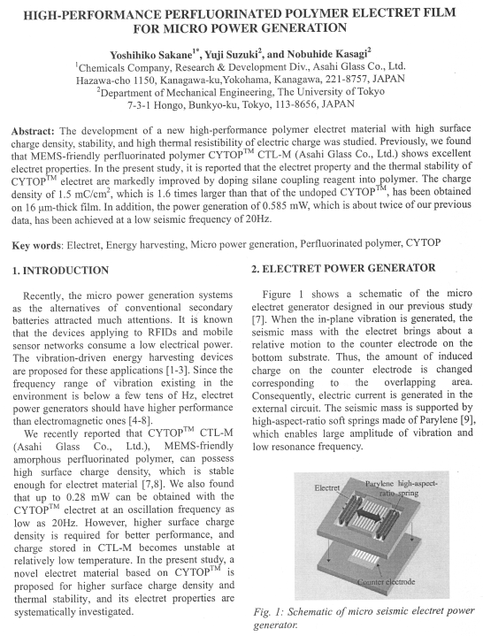

Страница 1

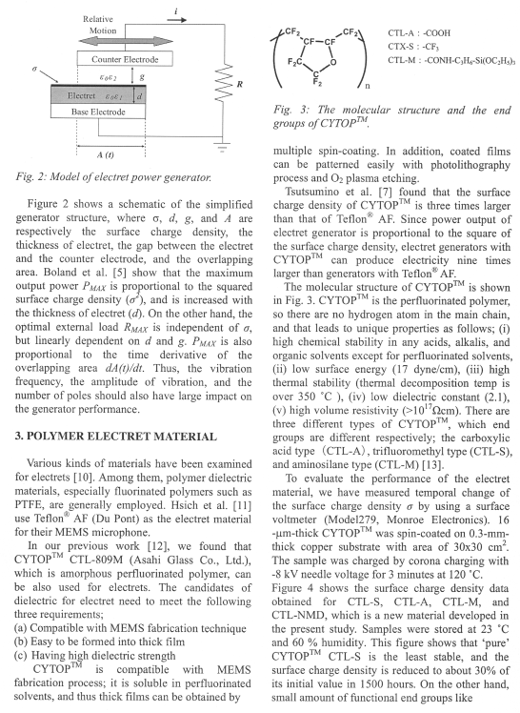
Страница 2

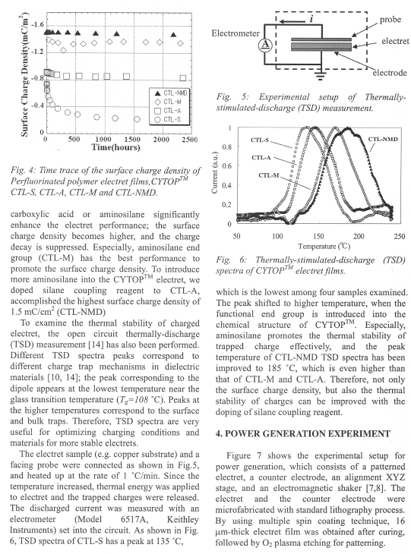

Страница 3

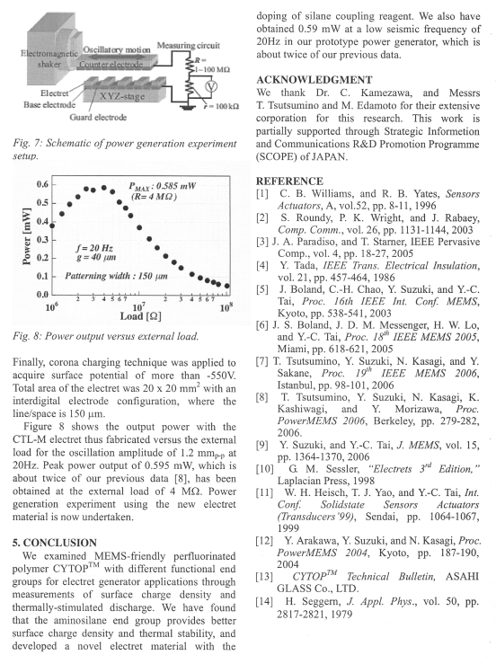

Страница 4

Appendix II
Схема-модель английской научной статьи

Субжанр (Subgenre) |  | Тематическое предложение (Moves)
Заглавие (Title)
Автор(ы), организация, адрес (Author(s), Affiliation, Address)
Аннотация  (Abstract) |  | - тема и цель исследования  (Subject and Purpose of Study)  - методы (Methods)  - результаты (Results)  - общие выводы (General Conclusion)
Введение  (Introduction) |  | - актуальность темы/исследования/ статьи  (Importance of the Study/ Paper)  - изложение истории вопроса  ( Background of Study)  - нерешенные вопросы (Lack of Knowledge)  - постановка цели исследования  (Focus/Purpose of Study/Paper)
Основная часть  (The Main Body) | Методы  (Methods) | - описание методов и методик  (Description of Methods and Techniques)  - описание оборудования и материалов  (Description of Equipment and Materials)  - описание условий и хода эксперимента (Experimental Conditions and Procedure)
Основная часть  (The Main Body) | Результаты  (Results) | - представление результатов (Presenting Results)  (с использованием графиков и таблиц)  (Using Figures/Graphs and Tables)
Обсуждение (интерпретация результатов) (Discussion)  (Interpretation of Findings) |  | - анализ результатов на фоне имеющихся данных (Analysis of Results)  - оценка результатов (Evaluation of Results)  - сравнение полученных результатов с ожидаемыми результатами  (Comparison of Findings with the Expected Findings)
Заключение  (Conclusion) |  | - описание значения результатов/ исследования  (Description of the Significance of Results/Study)  - общий вывод (General Conclusion)  - рекомендации для дальнейшего исследования  (Recommendations for Further Study)
Благодарность  (Acknowledgment) |  | -благодарность за помощь в исследовании  (Gratitude for Encouragement)  -благодарность за финансовую поддержку  (Gratitude for Support)
Библиография (References)
Приложение (Appendices)
Appendix III
Теоретические основы аннотирования
и реферирования
(Theoretical Review)

Основные понятия
Аннотирование и реферирование являются творческими процессами, суть которых состоит в осмыслении, анализе и оценке содержания оригинального текста с целью извлечения необходимых сведений. В результате аналитико-синтетической обработки информации получается вторичный текст, содержащий основные идеи первоисточника. К вторичным текстам относятся жанры аннотации и реферата.
Остановимся на их описании.
Реферат – это сжатое изложение основной информации первоисточника на основе ее смысловой переработки, строящееся в основном на языке оригинала и включающее фрагменты из первоисточника.
По цели (назначению) рефераты подразделяются:
– на библиографические рефераты;
– на рефераты для научно-популярных журналов;
– на учебные рефераты.
Выделяют следующие виды библиографических рефератов:
– в зависимости от глубины свертывания, степени компрессии (сжатия) информации первичного документа и характера представления материала:
а) информативный реферат (реферат-конспект);
б) индикативный реферат (указательный – краткий реферат, сходный с аннотацией).
Некоторые исследователи относят реферат-конспект и указательный реферат к репродуктивному виду реферата, то есть воспроизводящему содержание первичного документа. К продуктивному виду реферата, содержащему критическое или творческое осмысление реферируемого источника, относят реферат-обзор и реферат-доклад. Реферат-доклад, помимо анализа информации, приведенной в первоисточнике, дает объективную оценку состояния проблемы.
Информативный реферат определяется как реферат, содержащий в обобщенном виде все основные положения первичного документа, иллюстрирующий его материал, важнейшую аргументацию, сведения о методике исследования, используемом оборудовании, сфере применения. Поскольку такой реферат способен «до некоторой степени заменять первичный документ» он оказывает большую помощь читателям, которые не могут воспользоваться оригиналом.
Индикативный реферат характеризуется отсутствием детальной фактографической информации, касающейся результатов и выводов исследования, и наличием множества ключевых слов и словосочетаний, отражающих названия разделов, глав, рубрик. Именно эта особенность индикативного реферата помогает читателю решить вопрос о целесообразности обращения к первоисточнику.
– по цели реферирования или по читательскому назначению:
а) общий (универсальный), рассчитанный на широкий круг читателей;
б) специализированный, ориентированный на специалистов определенной области знания.
– по количеству реферируемых первичных документов:
а) монографический реферат (по одному первоисточнику);
б) обзорный реферат (на одну тему по нескольким источникам);
В рамках программы подготовки магистрантов по английскому языку рекомендуется написание информативного монографического специального реферата (объем – 1/8 от первичного текста) на основе информационной переработки профессионально-ориентированного (научно-технического) текста.
Построение текста реферата может иметь следующую композиционно-смысловую структуру:
1. Библиографическое описание (название статьи, выходные данные, сведения об авторе (авторах);
2. Тема;
3. Изложение основных вопросов, проблем, положений о которых говорится в первоисточнике;
4. Анализ самых важных, по мнению автора реферата, вопросов, перечисленных выше;
5. Выводы автора первоисточника по проблеме.
Аннотация, в отличие от реферата, является текстом, содержащим лишь перечисление главных вопросов первичного источника, указание на его тематику и структуру, при этом не допускающим цитирования.
Аннотация – это наикратчайшее изложение содержания первичного документа, дающее общее представление о теме и характеризующееся наличием языковых оценочных клише.
Аннотации классифицируют следующим образом:
– по содержанию:
а) справочные;
б) описательные (раскрывают тематику первичного текста, но не дают критической оценки);
в) рекомендательные (оценивают первоисточник с различных точек зрения);
– по полноте охвата содержания аннотируемого документа и читательскому назначению:
а) общие;
б) специализированные.
Разновидностью специализированной аннотации является и аналитическая аннотация, характеризующая определенный аспект содержания первоисточника. Выделяют также обзорную аннотацию, которая содержит обобщенную характеристику двух и более документов, близких по тематике.
– по адресату:
а) не для личного пользования;
б) для себя;
– по форме:
а) устные;
б) письменные;
– по объему:
а) краткие аннотации (обычно сводятся к характеристике первоисточника по одному аспекту);
б) развернутые аннотации (более подробно представляют первоисточник);
– по наличию автора:
а) неавторская аннотация, сопровождающая новую публикацию;
б) авторская аннотация, написанная известным, авторитетным лицом или автором, не известным широкому кругу читателей.
При аннотировании научно-технического текста магистрантами рекомендуется написание описательной общей аннотации, представляющей собой 3–4 четких предложения, дающих представление о главной теме и перечне вопросов, затрагиваемых в тексте первоисточника.
В структуре аннотации выделяют следующие части:
1. Библиографическое описание (название статьи, выходные данные, сведения об авторе (авторах));
2. Тема;
3. Проблематика.
Таким образом, если аннотация лишь перечисляет вопросы, о которых идет речь в первичном тексте и отвечает на вопрос «О чем говорится в первоисточнике?», то реферат не только перечисляет эти вопросы, но и раскрывает их существенное содержание, отвечая на вопрос «Что говорится в первоисточнике?».
Наряду с традиционными жанрами вторичной информации – рефератом и аннотацией, рекомендуется написание так называемых резюме-выводов, или сжатых выводов, содержащих 2–3 четких, кратких, выразительных предложений, отражающих вывод, к какому пришел исследователь после прочтения статьи (текста) по специальности.
Особое внимание следует уделить учебно-научному информативному монографическому реферату, написание которого характеризуется высокой степенью творческой аналитико-синтетической переработки информации. Процесс построения учебно-научного монографического реферата основывается на чтении научного текста, главным образом научной статьи по специальности с последующим написанием собственного вторичного текста, исключающего компиляцию – механическое переписывание отрывков первоисточника. Поскольку текст учебно-научного реферата является результатом информационной переработки английской научной статьи, его структура будет иметь компоненты, отраженные в схеме-модели учебно-научного монографического реферата.

Схема-модель учебно-научного монографического реферата
- Библиографическое описание
1.1. Название статьи, выходные данные
1.2. Сведения об авторе (авторах)
- Вступление (Introduction)
2.1. Тема, ее актуальность (Importance of the Study/ Paper)
2.2. Степень разработанности темы:
- история вопроса наиболее важные работы, посвященные данной теме, сведения об авторах (Background of Study);
- нерешенные вопросы (Lack of Knowledge)
- постановка цели исследования (Statement of Purpose)
- Основная часть (The main body)
3.1. Изложение основных вопросов, проблем, положений о которых говорится в статье
- описание методов и методик (Description of Methods and Techniques);
- описание оборудования и материалов (Description of Equipment and Materials);
- описание условий хода эксперимента (Experimental Conditions and Procedure);
- описание полученных результатов (Presenting Results)
3.2. Анализ самых важных, по мнению автора реферата, вопросов, перечисленных выше
- Заключение (Conclusion)
4.1. Вывод, описание значения результатов/исследования, сделанные автором статьи (Description of the Significance of Results/Study)
4.2. Обобщенный вывод о значении темы или проблемы статьи, сделанный автором реферата (General Conclusion)
Написание вторичных текстов на английском языке требует использование устойчивых выражение (клише). В помощь магистранту предлагается список наиболее часто употребляемых клише при аннотировании и реферировании в соответствии со структурой жанра.
По причине отсутствия в отечественной и зарубежной методической литературе единого мнения относительно терминологии на английском языке, используемой для обозначения того или иного жанра, в данном пособии принимаются следующие обозначения:
Abstract – описательная общая аннотация (объем – 3-4 предложения) (не следует путать с аннотацией к статье);
Summary (1) – информативный монографический специальный реферат (объем – 1/8 от первичного текста);
Summary (2) – резюме-выводы (объем 2-3 предложения);
Summary (3) – учебно-научный монографический реферат (объем – 1/5 от первичного текста), в зависимости от учебного плана специальности может иметь название Course Paper – Курсовая работа

Рекомендации по написанию реферата и аннотации
При реферировании и аннотировании работа ведется по следующим направлениям:
- выделение основной (главной) и отсечение второстепенной и несущественной информации;
- переработка (перефразирование) главной информации в краткую форму речевого произведения.
Для успешно выполнения поставленных задач следует придерживаться следующего алгоритма:
- Просмотрите бегло первичный документ, определите общий смысл текста, опираясь на заголовок, графики, рисунки;
- Прочитайте текст внимательно во второй раз для целостного восприятия информации, определите значение незнакомых слов по контексту и по словарю;
- Определите основную тему текста;
- Проведите смысловой анализ текста, выделяя абзацы (смысловые блоки, субтексты), содержащие информацию, которая раскрывает или подтверждает заглавие текста (основную тему); определите композиционное построение – структуру абзацев (дедуктивную – deductive, индуктивную – inductive, рамочную – closed-in, стержневую – pivotal);
Примечание. Проследить динамику изложения материала поможет анализ структуры абзаца или субтекста.
Абзац в научном тексте можно определить как относительно самостоятельный, графически выделенный посредством красной строки элемент текста, содержащий одну частную мысль или ее фрагмент. Классический абзац имеет абзацный зачин, главную абзацную фразу (обобщение), содержащую ключевые слова или предложение, комментирующую часть, раскрывающую утверждение главной абзацной части. Заканчивается абзац выводом. Иногда абзацный зачин является главной фразой, а комментирующая часть занимает два или более абзацев и вывод выделяется в отдельный абзац. В этом случае можно говорить о структуре субтекста.
Субтекст – компонент связного текста, развивающий одну из основных тем и обобщающий темы нескольких абзацев, входящих в его состав.
В зависимости от местонахождения в абзаце (субтексте) обобщающего предложения (key sentence) выделяют:
1) абзац (субтекст) с дедуктивной структурой – ключевое предложение находится на верхней границе абзаца (субтекста);
1) Модель дедуктивного (deductive) субтекста (абзаца)
2) абзац (субтекст) с индуктивной структурой – заключительное предложение или заключительный абзац, содержащие обобщение, подводят итог содержанию всего смыслового блока (куска) и находятся на нижней границе абзаца;
2) Модель индуктивного (inductive) субтекста (абзаца)
3) абзац (субтекст) с рамочной структурой – обобщение располагается в начале абзаца и в конце, при этом первое обобщение дублируется посредством перефразирования в конце смыслового куска;
3) Модель субтекста (абзаца) с рамочной (closed-in) структурой
4) абзац (субтекст) со стержневой структурой – ключевое предложение, содержащее обобщение, располагается в середине абзаца или в среднем абзаце субтекста;
4) Модель субтекста (абзаца) со стержневой (pivotal) структурой
В структуре текста можно выделить абзац, выполняющий функцию связки между абзацами (субтекстами). Такой абзац обычно состоит из одного предложения и называется конструктивным.
- Установите средства межфразовой связи внутри абзаца (субтекста) для установления более точных его границ;
Примечание.
Предложения внутри абзацев могут быть связаны посредством:
а) повторений терминов (repetitions);
б) синонимов (synonyms);
в) антонимов (opposites);
г) местоимений (pronouns);
д) использования разных частей речи с общим корнем (например: to depend – dependence)
е) союзов, союзных слов, местоименных наречий и наречий (Connectives) (см. Прил. 2) и т. д.
6. Распределите материал текста первоисточника на три группы по степени важности:
а) наиболее важная информация;
б) второстепенная информация;
в) малозначительная информация, которую можно опустить;
7. Найдите ключевые предложения в абзацах (в начале, середине или конце), содержащих существенную информацию, составьте логический план (назывной, вопросный, тезисный) или информационный граф текста;
Примечание. Наиболее рациональной формой фиксации понятого главного содержания текста является составление плана.
План – краткая программа изложения содержания статьи (текста), содержащая последовательное изложение коротко сформулированных мыслей-заголовков, по которым можно получить представление о содержании и схеме построения первоисточника.
По структуре выделяют:
1) простой план;
2) сложный план, содержащий подпункты;
3) развернутый, содержащий не только перечисление основных идей, но и выдержки из текста;
По форме выделяют:
1) назывной, состоящий из назывных предложений (словосочетаний);
2) вопросный, в форме вопросов с использованием вопросительных слов;
3) тезисный, состоящий из утвердительных предложений.
Назывные предложения плана легче всего преобразовывать в реферативные предложения, формулирующие главную мысль каждого раздела.
Еще одним способом отражения структурной организации содержания первоисточника является составление информационного графа или графической репрезентации текста, основанной на визуальном моделировании смысловой структуры целого текста. Например, текстовая схема (граф) текста, содержащего информацию о классификации материалов, может иметь следующий вид:

8. Перефразируйте, используя клише и слова с обобщенно-абстрактным значением, пункты плана в краткие (реферативные) предложения, формулирующие главную мысль каждого смыслового блока и важнейшие доказательства, подкрепляющие эту мысль;
Примечание. Перефразирование (реферирование) может осуществляться по предложенным образцам:
Х is a material that … | => | The author describes X as a material that …
 |  | X is described as a material that …
X are classified into…  X are divided into …  X fall into … | => | The author gives the classification of X.
X is important … | => | The author points out to the importance of X.
X is made thoroughly… | => | The author says about thorough X.
X can be described … | => | It is said about the opportunity to describe X…
X is bigger than Y. | => | The author compares X and Y.
X consists of …  X includes …  X contains …  X has… There is … . … is also present. | => | It is said about the construction of X.  The author describes the composition of X.  The design of X is presented.
X increases …  X decreases … | =>  => | The author says about higher (increased) X.  It is said about an increase in X/  The author points out to lower (decreased) X.  It is pointed out to a decrease in X.
There is a X … | => | The author says about the availability of X …
X is used for / in … | => | It is said about the use of X for/in …  The use of X for/in … is considered.
… | => | …
9. Завершите обработку всех пунктов плана, соединив предложения при помощи средств связи (см Приложение 5), в цельный, логично построенный в соответствии со схемой-моделью жанра вторичный текст.

Стилевые и языковые характеристики реферата и аннотации
Реферат и аннотация как жанры научного стиля имеют следующие стилевые характеристики:
– обобщенно-отвлеченность – в основе реферирования лежит использование приемов перефраза и обобщения:
а) резюмирующего, заключающегося в замене частного общим, видового понятия родовым, вскрытии общих признаков у ряда явлений для их объединения, сведении ряда явлений к их сущности, логическом развитии понятий, например замене одного признака другим, замене причины или следствие процессом и т. д.;
б) выборочного, означающего выделение одного наиболее типичного и показательного факта в качестве обобщенной характеристики положений материала;
– логичность изложения – в тексте прослеживается движение от простого к сложному, от старого знания к новому, от понятия к суждению и выводам. Кроме того, жанр реферата и аннотации имеют структуру, соответствующую модели жанра и соединение компонентов внутри текста достигается посредством многообразия средств межфразовой связи;
– терминологичность – термин – эмоционально-нейтральное слово (словосочетание), точно передающее название определенного понятия, относящегося к той или иной области науки и техники. Научно-технический текст содержит большое количество специальной терминологии, позволяющей наиболее четко и экономно излагать содержание данного предмета и обеспечивающей правильность понимания сути рассматриваемого вопроса. Отсюда вытекают такие особенности реферата и аннотации как, однозначность, предельная краткость, ясность.
Для языка и стиля реферата и аннотации характерно:
- преобладание слов с обобщенным, абстрактным значением (explanation-объяснение, description-описание, conditions-условия, estimation-оценка (результатов), etc.);
- наличие специального лексического аппарата – терминологии (AC generator-генератор переменного тока, electromotive force-электродвижущая сила, resistivity-удельное сопротивление, etc.);
- преобладание отглагольных имен существительных (determining-определение, implementing-внедрение, conducting-проведение, etc.);
- в глагольных формах преобладание настоящего простого (Present Simple), преимущественно в страдательном залоге; использование пассивных конструкций (The results of the experiment are presented. It is said about materials with high resistivity, etc.);
- активное использование повторений, лексических и грамматических, для обеспечения логико-смысловой связи между частями текста и отдельными фразами, например, личных, указательных, притяжательных и относительных местоимений; союзов и союзных слов и других средств связи (however-однако, besides-кроме того, thus-таким образом, etc.)
- употребление причастий и причастных оборотов;
- привнесение в текст клишированных конструкций, отсутствующих в первичном тексте (The experience of … is summarized in the article. The methodology of … is described in the paper., etc.);
- отсутствие субъективно-оценочной лексики.
Таким образом, соблюдение выше перечисленных особенностей помогает создавать тексты вторичных жанров аннотации и реферата в соответствии с требованиями, предъявляемыми к написанию текстов научного стиля, а, следовательно, эффективной текстовой деятельности.

Appendix IV
Клише для аннотирования и реферирования

The paper/text is entitled …
is called …
is named …
The title of the paper/ text is …
The paper / text is published in…
The author (s) of the paper is (are)…
The article/ text is written by …
The present paper/ text deals with…
The paper/ text under discussion (consideration) is concerned with …
is devoted to …
The paper/ text considers …
discusses …
describes …
gives a brief account of …
contains a survey of
presents a picture of ….
provides information on …
reviews briefly …
touches upon the issue of...
is about …
centers round the problem of...
presents some data on …
contains information on …
The paper/ text is intended (aims) to describe (explain, characterize) …
The paper/ text under consideration is mainly focused on … issues:…
considers (describes) the following main issues: …
First/ firstly, …. is/are discussed ( described, shown, considered) in the paper/ text.
The paper/ text begins with the discussion of …
The first part deals with …
In the first part the problem of … is considered in detail.
The first part concentrates (focuses) on …
The introductory part reviews …
Then/ Secondly … is/ are analyzed (considered, reviewed).
The author goes on to show that …
Also/ In addition the problem of … is considered.
Besides, some comments on … are given.
Then the author makes an attempt to show that …
The paper/ text also presents some data on …
The paper/ text also mentions the fact that …
The paper/ text also contains …
Besides, the paper/ text touches upon the problem of …
The mechanism of ... was/has been investigated using the method / technique of ...
The structure of ... was/has been studied by (the method of) ...
The phenomenon of … was/has been analyzed (by means of) ....
The process of ... was/has been examined making use of technique of ...
The function of ... was/has been analyzed by ...
Finally, the relationship between …was/has been established.
the interaction between … was/has been determined.
the parameters of ... were/have been calculated.
some information concerning ... was/has been obtained.
the properties of ... were/have been evaluated.
It was/has been found that …
It was/has been shown that …
It was/has been suggested that …
It was/has been concluded that …
Special attention is paid (given, called) to…
… is/ are of special importance ( significance, interest)
It is stressed (underlined, emphasized) that …
Much attention is focused on …
… is/are emphasized ( underlined, stressed, pointed out)
Summing up, the author points out that …
Summing up the discussion, the author emphasizes that …
Summarizing, the author says that …
To summarize, the author says that …
In conclusion, the author emphasizes that …

Appendix V

Средства связи
 | Значение | Средство связи
1 | Указание на порядковую последовательность мыслей и действий (сначала, потом, наконец) | First, at first, first of all, at the beginning, to begin with – во-первых, сначала, прежде всего;  second, secondly – во-вторых;  next, further, then – далее, затем;  finally, lastly, at last, in the end – (и) наконец
2 | Присоединение к высказыванию нового предложения, содержащего дополнительные замечания, или развивающее мысли дальше (кроме того, помимо того) | in addition – в дополнение (к сказанному);  consequently – следовательно, вследствие этого;  accordingly – в соответствии с этим;  therefore – поэтому  moreover – кроме того, более того;  furthermore – далее, более того, кроме того, к тому же;  also – кроме того, более того, а также;  likewise, similarly – точно так же, аналогичным образом;  besides – кроме того  what is more – более того
3 | Выражение противопоставления | however – однако;  still – однако, тем не менее;  yet – однако, однако же;  on the contrary, in (by) contrast – и наоборот, напротив, в противоположность этому;  conversely, alternatively – с другой стороны;  on the one hand – с одной стороны;  on the other hand – с другой стороны;  nevertheless – тем не менее, несмотря на это, однако;  otherwise – иначе, противном случае  although – хотя

Продолжение таблицы
 | Значение | Средство связи
4 | Указание на следствие, суммирование сказанного ранее | hence – отсюда;  therefore – поэтому  consequently, as a consequence  thus – таким образом;  as a result – в результате этого;  in brief, in short, briefly, in a few words вкратце короче говоря; – вкратце;  in sum, to sum up, to summarize – итак, суммируя сказанное выше, можно сказать, что…
5 | Выражение ссылки на что-либо | according to, with reference to – согласно …, в соответствии с …  as for – что касается…  with respect to, with regard to, regarding – относительно …
6 | Выражение причины | because of, owing to, due to – из-за, благодаря;  for this reason – по этой причине
7 | Приведение примеров | for example, for instance – например  as an example – в качестве примера

